Question 2: Execute various LINUX commands for:
I. Information Maintenance:
- wc : print newline, word, and byte counts for each file
- -w : this option counts only words

- clear: Clears the terminal screen
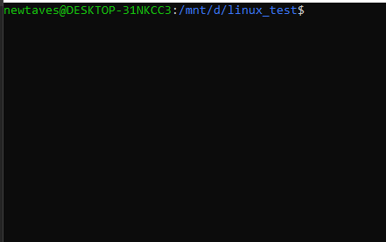

- cal : The cal utility displays a simple calendar in traditional format and ncal offers an alternative layout, more options and the date of Easter. The new format is a little cramped but it makes a year fit on a 25x80 terminal. If arguments are not specified, the current month is displayed.
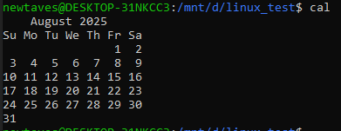
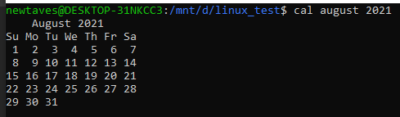

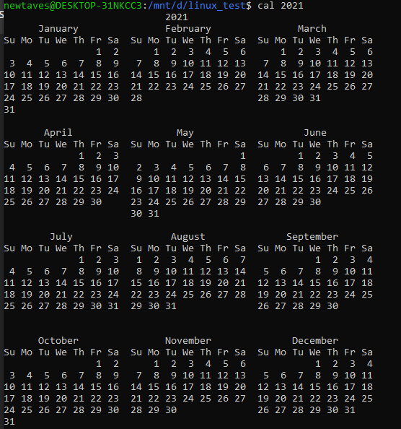
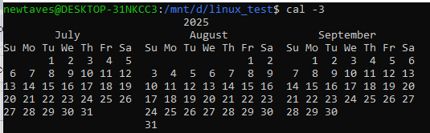
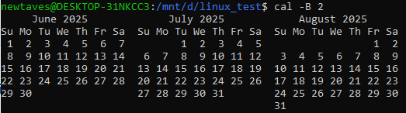
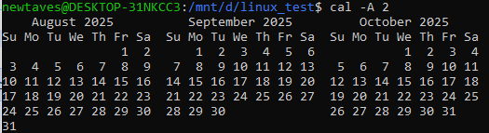

- who: Print information about users who are currently logged in.

- date: Display date and time in the given FORMAT. With -s, or with [MMDDhhmm[[CC]YY][.ss]], set the date and time.

- pwd: Print the full filename of the current working directory.

II. File Management:
      - cat: concatenate files and print on the standard output Can be used to make new files
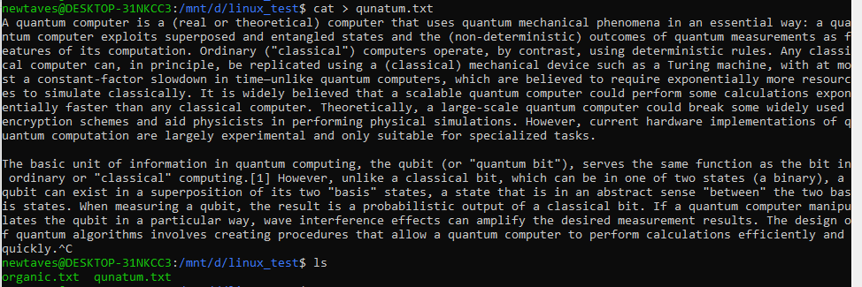
Combines output of two files
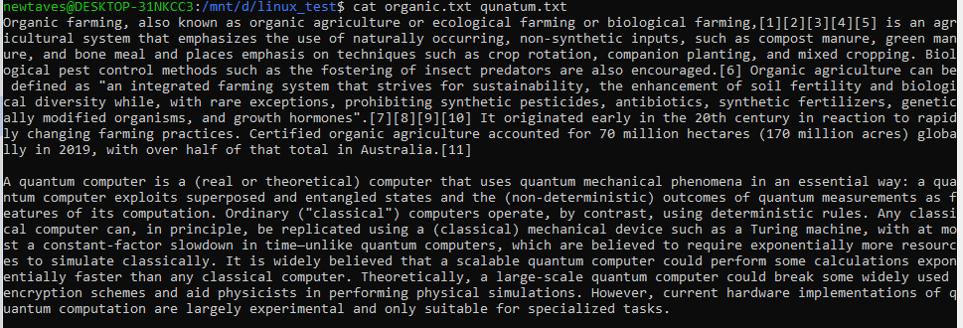

      - cp : copy files and directories
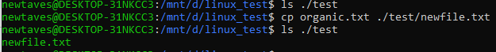

      - rm: removes files or directories
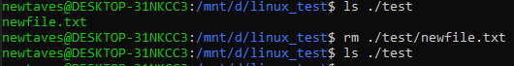

      - mv: Rename SOURCE to DEST, or move SOURCE(s) to DIRECTORY.
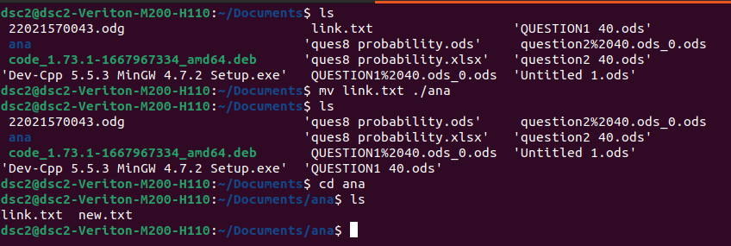
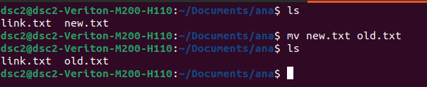

      - cmp : Compare two files byte by byte and tell where the file is different.
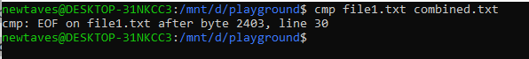

- comm: The comm command in Linux is a utility used to compare two sorted files line by line. It identifies and displays lines that are unique to each file and lines that are common to both
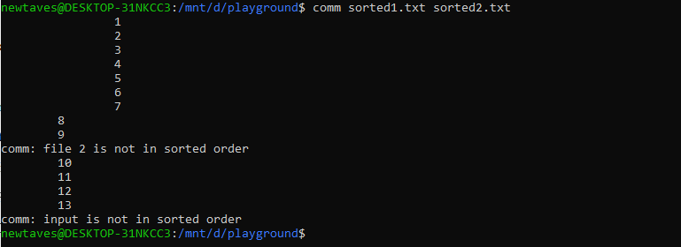
- diff: compares files line by line
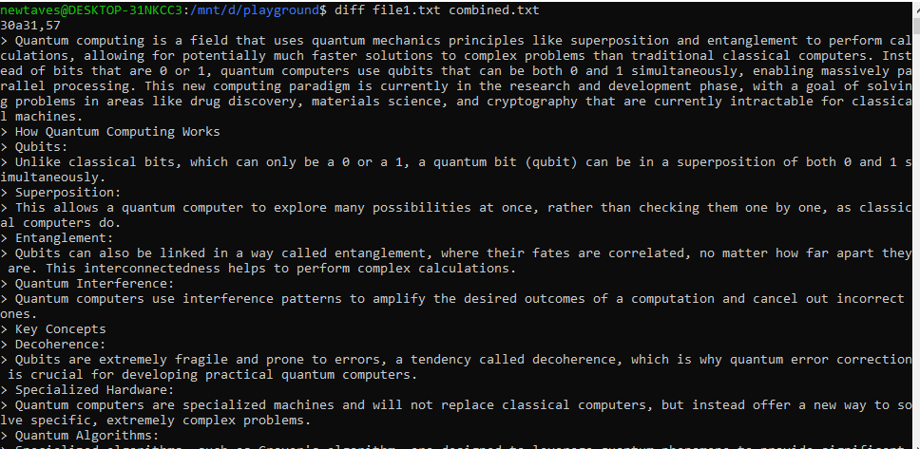
diff -i : ignores the case of content of files
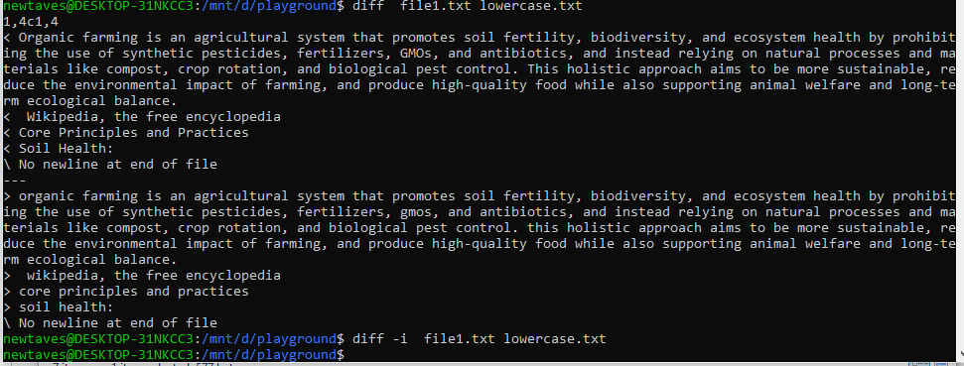
- find : used to locate file or folders in a directory
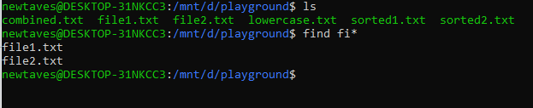

- grep: Searches for word/expression/pattern in a file
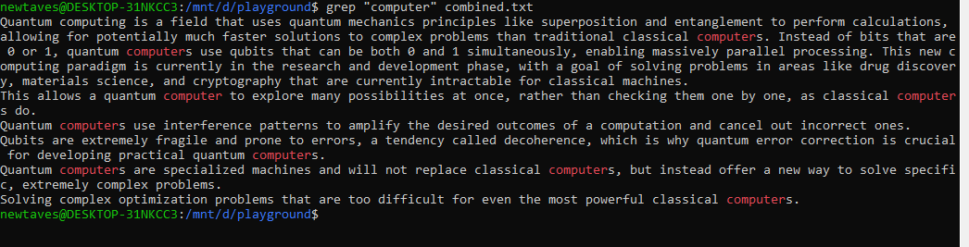
Options: -i case- insensitive i.e. ignores the case
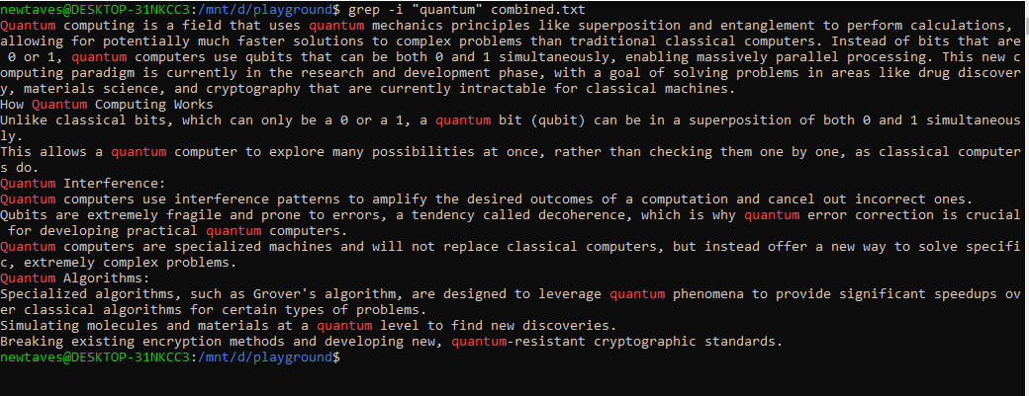
-c : prints the number of times search query occurs
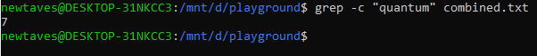

- Awk: awk is the GNU Project's implementation of the AWK programming language.
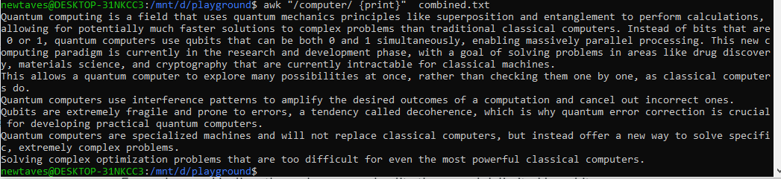

III) Directory Management
      - cd : change the shell directory.
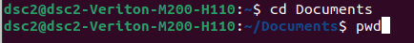
- ‘..’ is processed by removing the immediately previous pathname component back to a slash or the beginning of DIR.
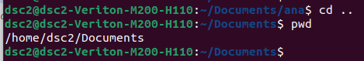

      - mkdir: used to create new directories
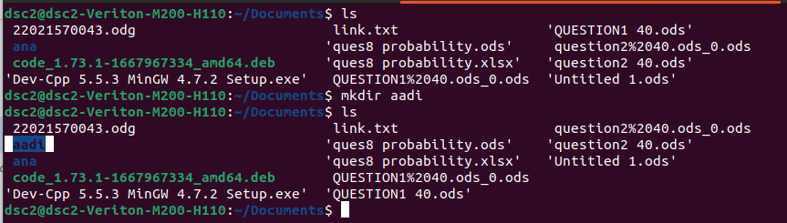

      - rmdir: Used to remove directory
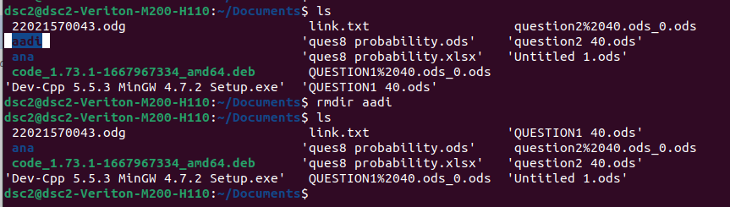

      - ls: used to list contents of directory
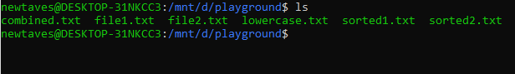

Options:
-l : prints details of the files
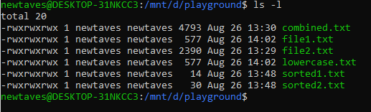

-a : prints hidden files also
